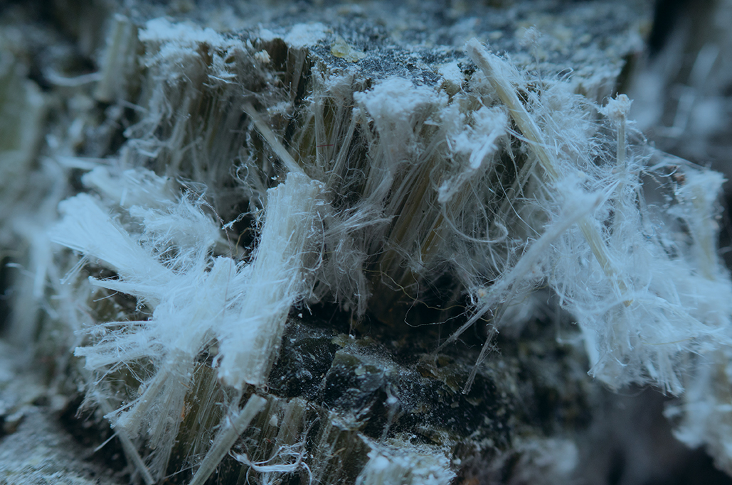





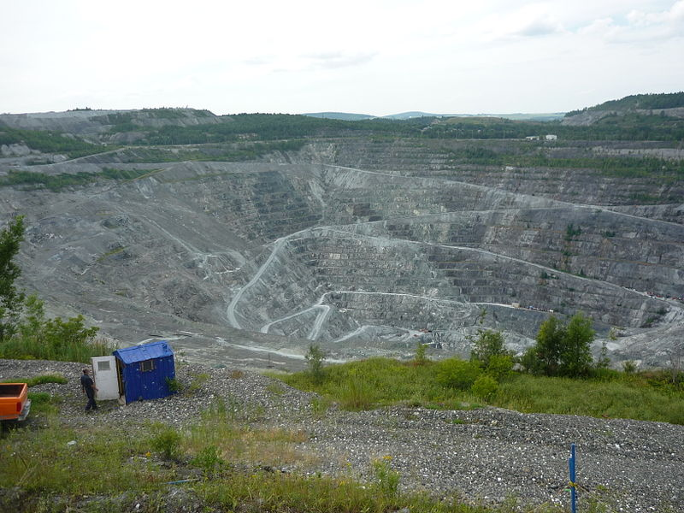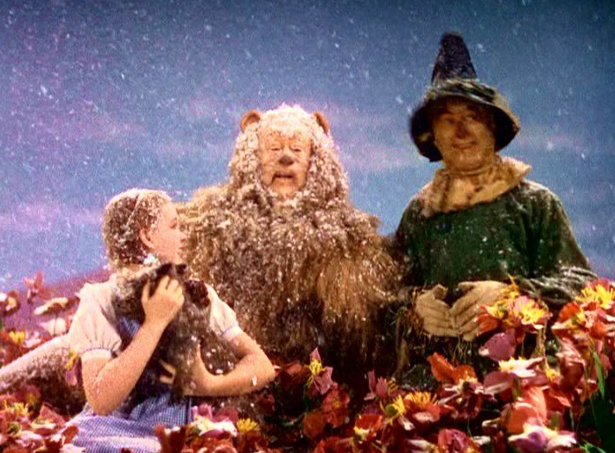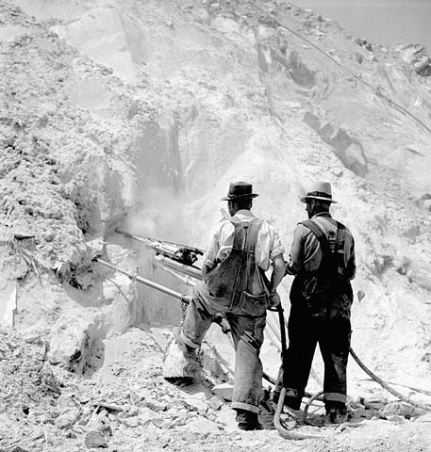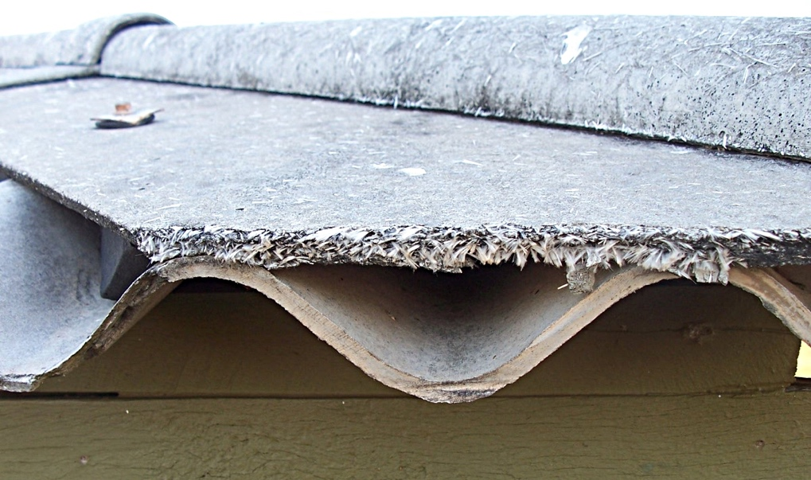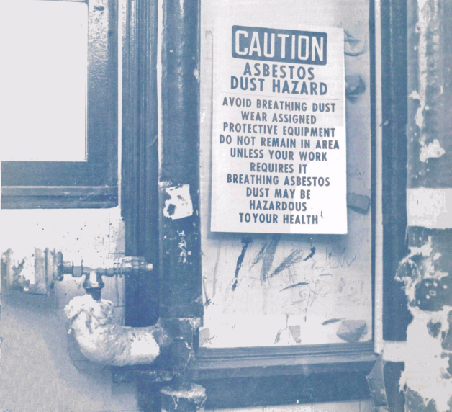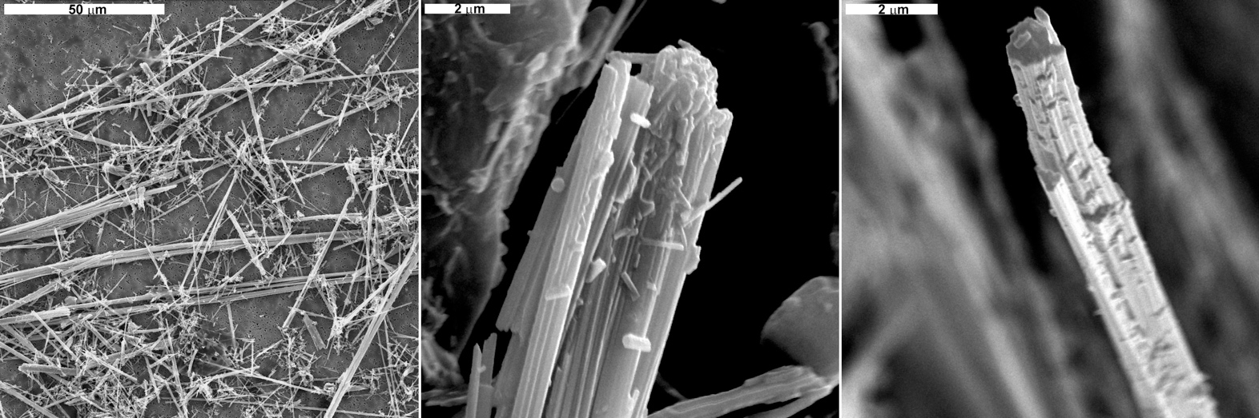

**It wasn’t until the early 1970’s when the EPA and OSHA started regulating asbestos.**

**Asbestos was once common in many household products and often referred to as the “miracle fiber.” It was used as fake snow in the *Wizard of Oz* (1939), in the scene where Dorothy and her companions began getting snowed on while lying unconscious in the poppy field, under a sleep spell by the Wicked Witch.**

**Asbestos related diseases have a long latency period. That means many of the people dying from mesothelioma today were exposed to asbestos in the 1960’s and 1970’s.**

**Asbestos is banned in 55 countries worldwide, but not in the United States.**

**Today, asbestos is still used in automotive products like gaskets and brake pads, vinyl tile, and roofing products.**

**Asbestos poses a health risk when its fibers are released into the air and inhaled or digested. These fibers are too small to be seen by the naked eye.**

**Asbestos is a natural mineral product that is still mined today. It also can be found naturally in the environment in trace amounts through the air, soil, and water.**